Here are 3 pictures of my school:

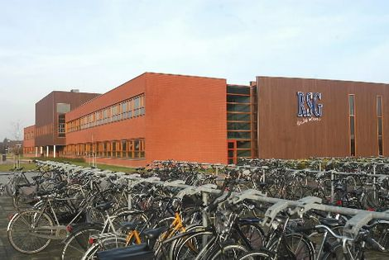

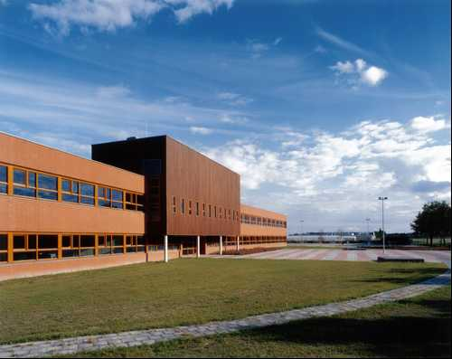

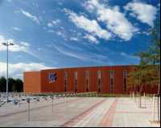 ( That blue sky is not always there xD )

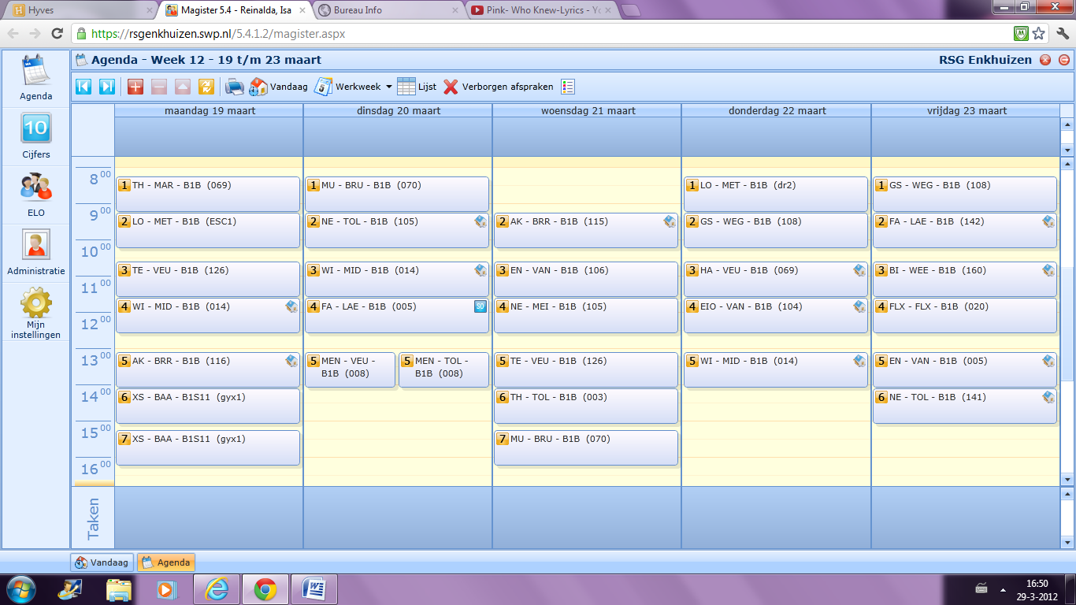**SCHOOL TIMETABLE**

Here is a picture of the school timetable:

TH: Technology MU: Music BI: Biology

LO: Physical education NE: Dutch FLX: Flex

TE: Art FA: French EIO: Extra English.

WI: Mathematics MEN: Mentor hour

AK: Geography EN: English

XS: Sport stream GS: History

 **THE school**

**A day at my school:**

If I take for example Monday. I get on my bike at 7.15 a.m. I pick up some friends and I arrive at school at 8.00 a.m. I put my jacket, gym bag and some books in my locker and got to my class which starts at 8.15 am. My first hour is Technology I’m going to work on my project: A wooden box with lights. After that hour I have P.E. which starts at 9.15 a.m. We shall probably play volleyball because we have a tournament coming up. After P.E. I have a break, this will take 20 minutes so my next lesson starts at 9.35 am. This will be Art. I work further on my portrait of a class mate. My next lesson starts at 10.35 a.m. It’s mathematics. We are going to talk about rotation symmetry. Then I have a break, sometimes in that break I’m going to the mall. After that break which takes 30 min. the next lesson is geographics it starts at 1.05 p.m. Then at 2.05 p.m.starts sport stream. The first hour till 3.05 p.m.I have gymnastics the teacher is going to mark me for my flip. Then there is a break of 10 min. after that I play badminton for an hour. At 4.15 p.m. I go home.

|  |  |  |
| --- | --- | --- |
| **English** | **Dutch** | **Abbreviation** |
| Dutch | Nederlands | NE |
| English | Engels | EN |
| French | Frans | FR |
| EIO | EIO | EIo |
| History | Geschiedenis | GS |
| Geographic | Aardrijkskunde | AK |
| Mathematics | Wiskunde | WI |
| Biology | Biologie | BI |
| Music | Muziek | MU |
| Art | Tekenen | TE |
| Craft | Handvaardigheid | HA |
| P.E. | L.O. | LO |
| Technology | Techniek | TH |
| Flex | Flex | FLX |
| Stream | Stroom | XS |
| Mentor hour | Mentor uur | MEN |

**Subjects:**

On the RSG I have lessons of an hour. In one week I have 29 lessons. These are de subjects I have.

Special lessons:

Some lessons I have on the RSG are a little bit different than the others. Now I going to explain what you do in these lessons.

EIO – EIO is only for DLE classes one hour extra in a week. You can see EIO as an extra English lesson but we do a lot of fun things. During EIO I write letters to you.

Flex – If you find a subject hard or if you problems with the chapter you are at you can during flex have extra practise. First you choose two subjects ( for example English and Mathematics). Then if you have flex you practise in the first half hour English and in the second mathematics.

Stream - Stream is two hours a week. At the beginning of you choose a stream. These are your choices:

**Physic stream** – With Physic stream you do different sports every time like rugby, soccer, gymnastics and tennis and sometimes you are going to ski, ice-skate and windsurf. I chose Physic stream.

**Art and Culture** – With Art and Culture you are going to make things with your hands like animals of papier-mâché and little statues of clay but you are also going to act and dance.

**Science and ICT** - With science and ICT your going to make your own game on the computer and you are going to learn how to sovel technical problems.

**Broad stream –** With broad stream you are going learn things about life circumstances. You won’t be specialized in one thing.

Mentor hour – Every class has its own mentor. You have the whole year the same mentor. With mentor hour you are going to discuss with your class what is going with the class.

This is my timetable:

**Pictures of my school:**

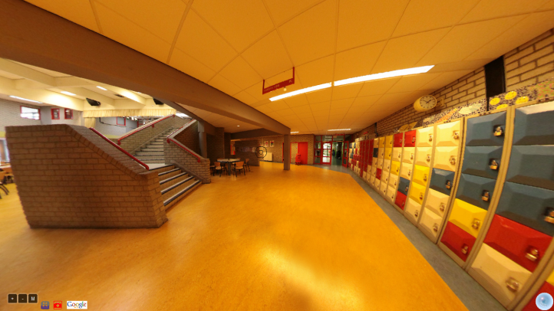

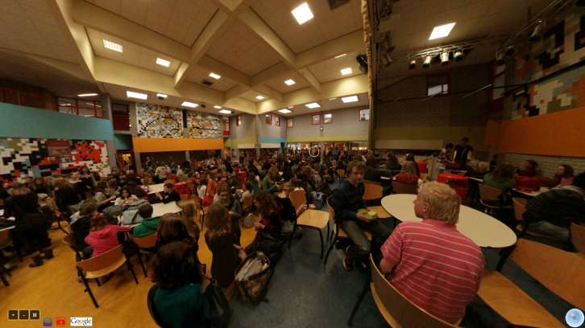 Big auditorium On the right hand side you can see my locker

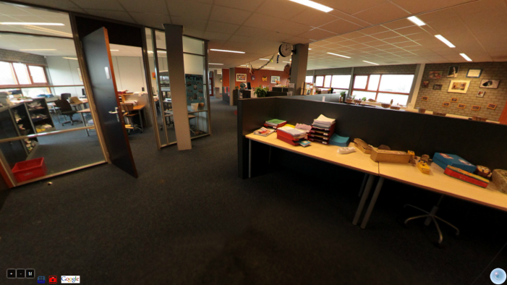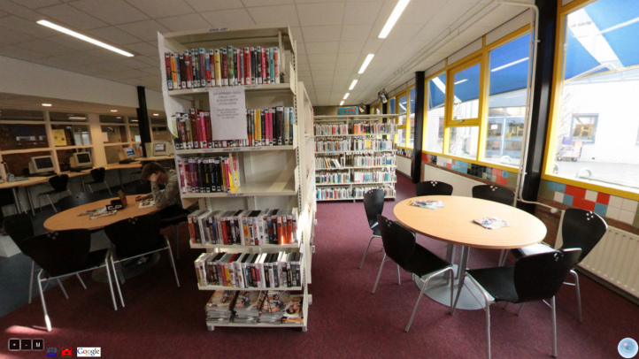 “mediatheek” first year domain

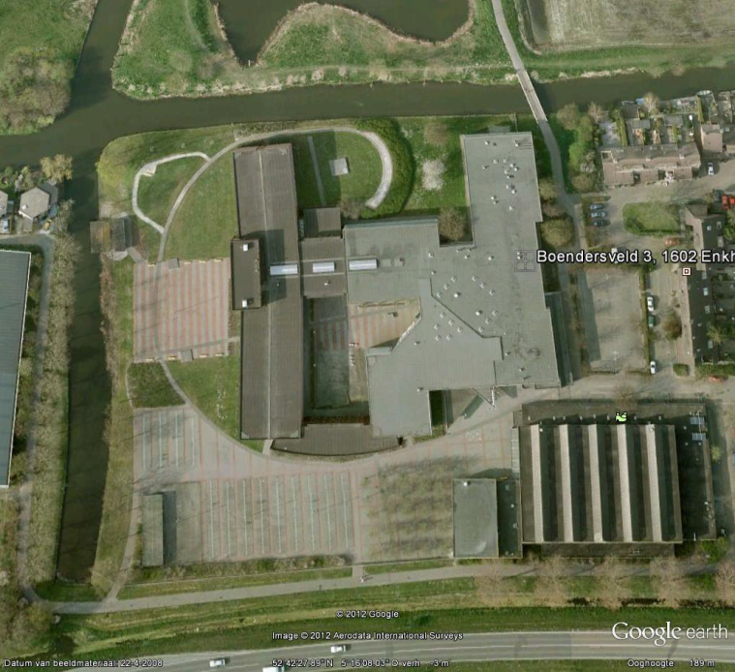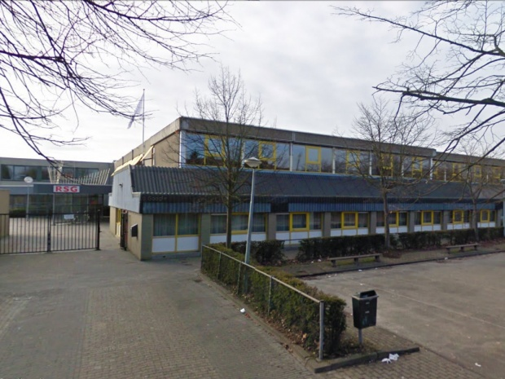

my school RSG Enkhuizen